WESLACO INDEPENDENT SCHOOL DISTRICT
319 W. 4th St.
Weslaco, Texas 78596

Norma Brewer,
Director
Priscilla Canales, Ph. D.
Superintendent of Schools

Week of Nov. 13-17
 | Weslaco ISD District Anti-Bullying Week Plan (Recommended)
Monday, Nov. 13th | Activity(s) | Describe the activity…
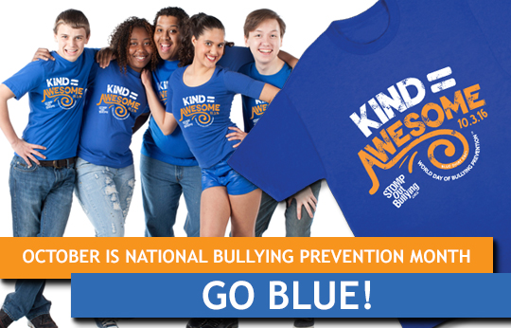 | United We Stand Against Bullying | Students and staff will wear a royal blue shirt to symbolize unity against bullying.
 | Anti-Bullying Pledge | Students will sign and display class/campus anti-bullying pledge.
Tuesday, Nov. 14th | Activity(s) | Describe the activity…
 | Be Someone’s HERO, Stand Up to Bullying | Students and staff are encouraged to wear their favorite superhero shirt.
Wednesday, Nov. 15th | Activity(s) | Describe the activity…
 | Hats off to Friendship! | Staff and Students are encouraged to wear hats to show support!
Thursday, Nov. 16th | Activity(s) | Describe the activity…
 | Bully Free from Head to Toe! | Staff and students are encouraged to wear crazy hair and socks to show support
Friday, Nov 17th | Activity(s) | Describe the activity…
 | Stomp Out Bullying | Staff and students are encouraged to wear boots and/or western wear to show support!

